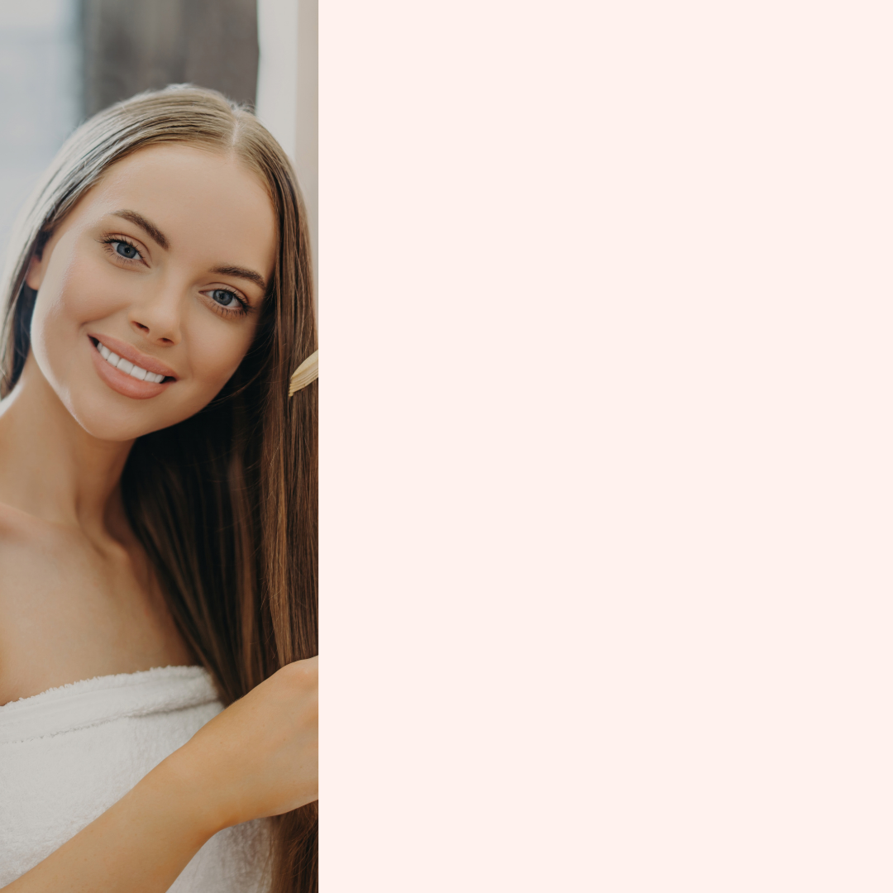
Hair Salon Price List

HAIR TREATMENT
Hair Wash …………………….………… $00
Creambath ……………………………… $00
Hair Mask …………………….………… $00
Creambath + Hair Mask………….. $00

COLOURING
Full Head Color …….………………… $00
Full Head Color + Bleaching …….. $00
Full Head Highlight …………………. $00

HAIR STYLING
[Write Service Description Here] $00
[Write Service Description Here] $00
[Write Service Description Here] $00

[Hair Salon Name]
+1 234 567 890
huguetemplate.net

