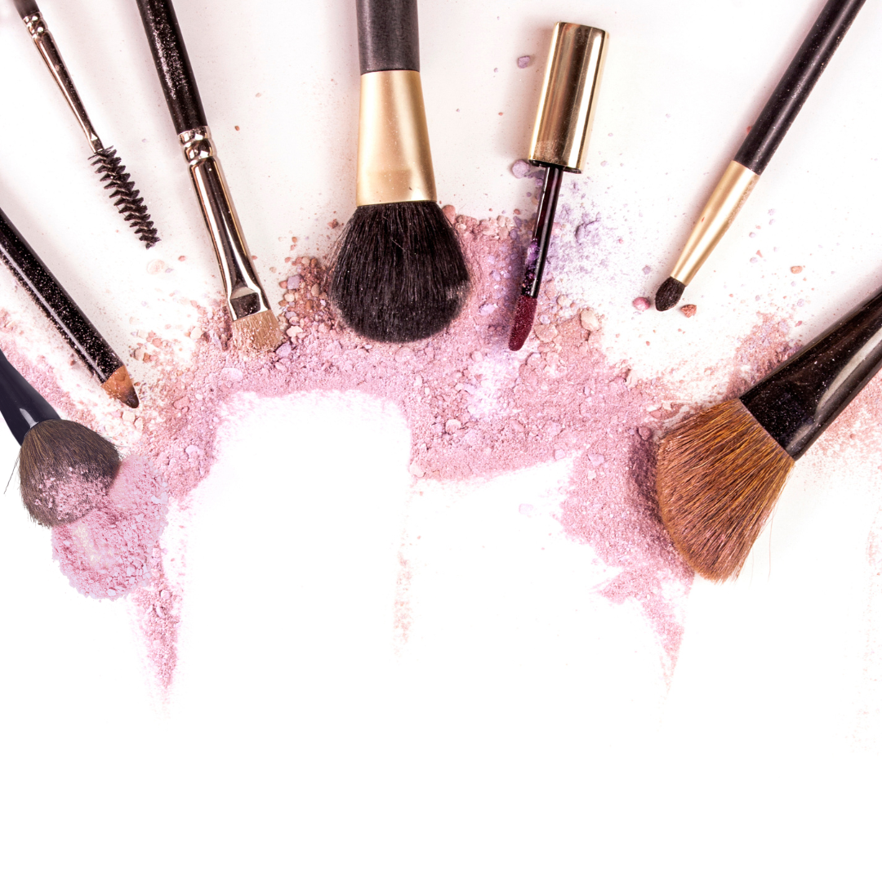

Makeup Price List

Make Up
Cleanse, Makeup & Lashes ……………………… $00
Cleanse & Makeup …………………………………. $00
Make-up Lessons……………………………….……. $00

Wedding
Bridal Makeup Trial ………………………………… $00
Bridal Makeup Package…………………………… $00
Bride Updo ………………….…………………………… $00
Ultimate Bridal Entourage Package ………… $00

Eye Care
Eyebrow Wax & Shape..…………………………… $00
Eyebrow Tint……………….…………………………… $00
Eyelash Tint……………………………………………… $00
Full Set of Lashes……………………………………… $00

